Qunoot - e - Naazilah
Dua for protection against Natural Disater, Plague and War.
When the Muslims Community is afflicted with some hardship then Qunoot-E-Naazilah should be recited in the Fajr Salaat.
Method: After the Ruku' of the second rakaat, while standing in the position known as Qaumah, the Qunoot should be read in a voice lower in tone thatn when reciting the Qiraat. The Muqtadees should place their hands at the side and say Ameen at the proper juncture.
Note: Women may also recite this dua softly.
One may recite it as often as possible as a dua.
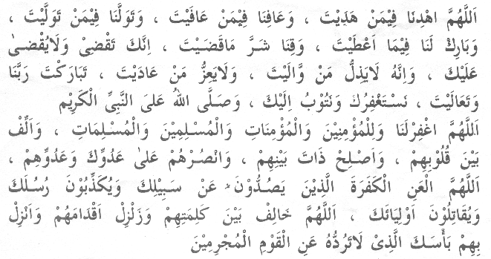
Translation :
O Allah, guide us aright along with those who have been rightly guided and grant us safety along with those that have been granted safety and support us along with those that have been supported and add Your Blessings to what You have given us and save us from the harmful effects of what You have ordained ( i.e. lest I should be wanting in cheerfully submitting to your Decrees) as You alone disposes and no one can dispose against You. Anyone who is under Your Protection cannot be lowered and anyone who is opposed by You cannot gain dignity; our Lord; You are full of blessings and Most High, we beg forgiveness from You and repent before You and may the blessings of Allah be showered on the Holy Prophet (Sallallaahu Alayhi Wa Sallam). O Allah, forgive us and the believing men and women and Muslim men and women, unite their hearts with mutual love, set right their mutual affairs and help them against theirs and Your enemy. O Allah, let Your curse be on those unbelievers who prevent people from treading Your path, who reject Your prophets and fight Your chosen ones. O Allah, make difficult their plans, shake their feet and give them such punishment which is not turned away from a sinning people.
Aameen
Issued by Al Jamiat Publications
579 West Street, Durban, 4001
(031) 3067786 - info@jamiat.org.za

METHOD OF QUNOOT-E-NAAZILA
· In Fajr Salaat, after the Ruku of the second Rakaat, the Imaam will make audible Du’aa. The Muqtadee (followers) will listen to the Du’aa and say, ‘Aameen’ softly during the pauses of the Imaam’s Du’aa. (Fataawa Mahmoodiyyah vol.2 pg.138)
· The Muqtadis will not recite the Du’aa with the Imaam. (I’elaa-us-Sunan vol.6 pg.120; Idaratul Qur’aan)
· The Imaam and the Muqtadis should not raise their hands during the Du’aa. The hands should be left by their sides. (Shaami vol.2 pg.9; HM Saeed)
· Upon completion of the Du’aa, they will go into Sajdah and complete the Salaat as normal.
1. Qunoot-e-Naazila may be recited by the Imaam during Fajr Salaat. A Munfarid (person performing Fardh Salaat individually) may not recite Qunoot-e-Naazila. (Shaami vol.2 pg.11; HM Saeed)
2. One may also recite Qunoot-e-Naazila in Nafl Salaat, performed individually during the night. (Fataawa Mahmoodiya vol.2 pg.138)
3. Females may also recite Qunoot-e-Naazila in Nafl Salaat.
THE QUNOOT (DU'AA)
Hadhrat Ibn Abbaas (Radhiallaahu Anhu) narrates: Rasulullah (Sallallaahu Alayhi Wasallam) would teach us the following Du'aa to be recited in the Salaat of Fajr:
refer www.alinaam.org.za
for arabic script of the du'aa
The Ulama have advised that the Du’aa should be according to the prevailing situation. (Subul-salaam vol.1 pg.186; Darun Nashril Kitaab)
Therefore, other Du’aas narrated in the Qur’aan or Hadith or such Du’aas not resembling Kalaamun-Naas (such speech that can be sought from people as well) may be recited in Arabic. To recite Du’aas during Salaat in any other language is Makrooh-e-Tahrimi. (Shami vol.1 pg.524;HM Saeed)
DARUL IFTA - MADRASAH IN'AAMIYYAH, CAMPERDOWN
Qunoot - E - Naazilah
At these trying times it is highly recommended to read the Qunoot-e-Naazilah. Whenever the Muslim Community is afflicted with some hardship then Qunoot-E-Naazilah should be recited in the Fajr Salaat.
Method: After the Ruku' of the second rakaat, while standing in the position known as Qaumah, the Qunoot should be read in a voice lower in tone than that when reciting the Qiraat. The Muqtadees should place their hands at the side and say Ameen at the proper juncture.
Note: Women may also recite this dua softly.
One may recite it as often as possible as a dua, in salaah and out of salaah.
Hadith 1
Hadhrat Nu’maan ibn Basheer (Radhiallaahu Anhu) narrates that Rasulullah (Sallallaahu Alayhi Wasallam) said, ‘You will see the believers in their mutual mercy for one another, mutual love for one another, and mutual companion for one another like a body. When one limb (of the body) complains, that effects the entire body by being awake and having fever.’ (Mishkaat pg.422; Qadeemi)
Hadith 2
Hadhrat Abu Musa (Radhiallaahu Anhu) narrates that Rasulullah (Sallallaahu Alayhi Wasallam) said, ‘A believer to a believer is like a building that strengthens one another (with each brick).’ (Ibid)
Hadith 3
Hadhrat Ibn Umar (Radhiallaahu Anhu) narrates that Rasulullah (Sallallaahu Alayhi Wasallam) said, ‘A Muslim is a brother of another Muslim, so do not oppress him and do not hand him over (to the mercy of the enemies when he is in trouble).’ (Ibid)
Hadith 4
Hadhrat Aamir ibn Maalik, the leader of the tribe of Bani Sulaym requested the help of Rasulullah (Sallallaahu Alayhi Wasallam) against the enemies of his tribe. Rasulullah (Sallallaahu Alayhi Wasallam) accepted his request and sent seventy Sahaaba (Radhiallaahu Anhum) who were Qurraa (experts in the recitation of the noble Qur’aan). The tribe of Banu Sulaym surrounded these Sahaaba (Radhiallaahu Anhum) by a place called Bir Ma’oona and murdered them. Jibraaeel (Alayhis salaam) informed Rasulullah (Sallallaahu Alayhi Wasallam) of the incident and conveyed to him the heartfelt message of the Qurraa: ‘Inform our people that we met our Rabb. He was pleased with us and (in turn) pleased us.’
This incident caused great grief to Rasulullah. Abdullah ibn Mas’ood (Radhiallaahu Anhu) narrates that Rasulullah (Sallallaahu Alayhi Wasallam) recited Qunoot Naazila for one month continuously cursing the tribe of Bani Sulaym. (Bukhari vol.2 pg.586; )
In view of the above, the Fuqahaa have ruled that when the Ummat is in a crisis, they should follow the Sunnah practise of Qunoot-e-Naazila and make Du’aa for the Ummah.Once again we are at crossroads and we should resort to the Sunnat practise of Qunoot-e-Naazila.
METHOD OF QUNOOT-E-NAAZILA
In Fajr Salaat, after the Ruku of the second Rakaat, the Imaam will make audible Du’aa. The Muqtadee (followers) will listen to the Du’aa and say, ‘Aameen’ softly during the pauses of the Imaam’s Du’aa. (Fataawa Mahmoodiyyah vol.2 pg.138)
The Muqtadis will not recite the Du’aa with the Imaam. (I’elaa-us-Sunan vol.6 pg.120; Idaratul Qur’aan)
The Imaam and the Muqtadis should not raise their hands during the Du’aa. The hands should be left by their sides. (Shaami vol.2 pg.9; HM Saeed)
Upon completion of the Du’aa, they will go into Sajdah and complete the Salaat as normal.
1. Qunoot-e-Naazila may be recited by the Imaam during Fajr Salaat. A Munfarid (person performing Fardh Salaat individually) may not recite Qunoot-e-Naazila. (Shaami vol.2 pg.11; HM Saeed)
2. One may also recite Qunoot-e-Naazila in Nafl Salaat, performed individually during the night. (Fataawa Mahmoodiya vol.2 pg.138)
3. Females may also recite Qunoot-e-Naazila in Nafl Salaat.
THE QUNOOT (DU'AA):
Hadhrat Ibn Abbaas (Radhiallaahu Anhu) narrates: Rasulullah (Sallallaahu Alayhi Wasallam) would teach us the following Du'aa to be recited in the Salaat of Fajr:
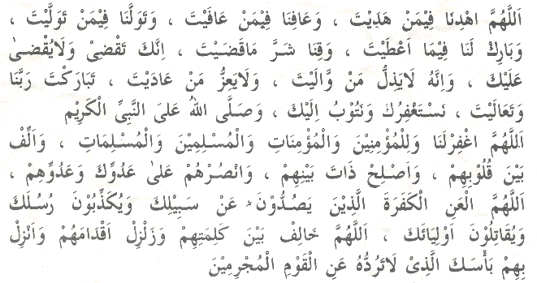
Translation : O Allah, guide us aright along with those who have been rightly guided and grant us safety along with those that have been granted safety and support us along with those that have been supported and add Your Blessings to what You have given us and save us from the harmful effects of what You have ordained ( i.e. lest I should be wanting in cheerfully submitting to your Decrees) as You alone disposes and no one can dispose against You. Anyone who is under Your Protection cannot be lowered and anyone who is opposed by You cannot gain dignity; our Lord; You are full of blessings and Most High, we beg forgiveness from You and repent before You and may the blessings of Allah be showered on the Holy Prophet (Sallallaahu Alayhi Wa Sallam). O Allah, forgive us and the believing men and women and Muslim men and women, unite their hearts with mutual love, set right their mutual affairs and help them against theirs and Your enemy. O Allah, let Your curse be on those unbelievers who prevent people from treading Your path, who reject Your prophets and fight Your chosen ones. O Allah, make difficult their plans, shake their feet and give them such punishment which is not turned away from a sinning people.
The Ulama have advised that the Du’aa should be according to the prevailing situation. (Subul-salaam vol.1 pg.186; Darun Nashril Kitaab)
Click Here To Listen To ‘Qunoot e Naazilah’

Working link ^
I

